NanoQuant: New technique for rapid quantification of extracellular vesicles

An internship position for Master students (Physics, Medical Natural Sciences, Biomedical Sciences) is available in conjunction between Dispertech B.V. and the Vesicle Observation Center of the Academic Medical Center. In our group, new treatment and diagnostic procedures based on innovative physical techniques are developed. Dispertech is a young and dynamic startup developing next-generation tools for extracellular vesicle research.
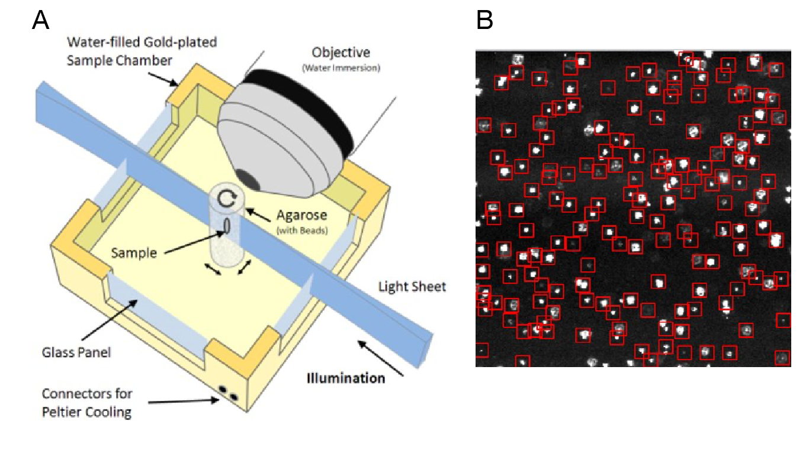
Figure 1. (A) Schematic of the nanoQuant device: a light-sheet microscope allows to capture an image of extracellular vesicles (EVs) immobilized in a Hydrogel. (B) Example frame and detection of fluorescently labelled particles in the microscope.

Background. Human body fluids are “liquid biopsies”. Analysis of the composition of “liquid biopsies” provides detailed insight in the health or disease status of an individual. A key component of body fluids are extracellular vesicles (EVs), which can be seen as biological nanoparticles. As the concentration, composition and function of EVs change in disease, accurate EV measurements together with sophisticated data analyses will likely provide new clinical information.
Problem. As most EVs have a diameter ≤100 nm, currently used detection techniques either overlook the majority of EVs due to a lack of sensitivity, or are too slow for routine clinical applications.
Solution. By combining sample immobilization in a hydrogel with a light-sheet microscope (Fig. 1A) we can achieve a detection throughput in the order of thousands of particles per second. Light-sheet microscopes are wide-field, which allow the simultaneous collection of light from hundreds of particles (Fig. 1B), while maintaining a sensitivity close to a single fluorescent molecule.
Proposed Project. Validating this new technique requires several well-designed experiments. The goals of the experiments are to (1) calibrate the fluorescence intensity, (2) determine the lower limit of detection of the fluorescence intensity, (3) investigate whether the technique can be used to determine the number of particles per volume of body fluids. For this project, we have state-of-the-art reference materials, a calibrated flow cytometer and of course the new technique available. You will learn the fundamentals of flow cytometry and fluorescence microscopy. At the end of the project, you will perform a proof-of-principle experiment to show the applicability of the technique to a real-world problem.
Contact: Dr. Aquiles Carattino (carattino@dispertech.com), Mona Shahsavari M.Sc. (m.shahsavari@amsterdamumc.nl), and Dr. Edwin van der Pol
Websites www.dispertech.com and www.edwinvanderpol.com

